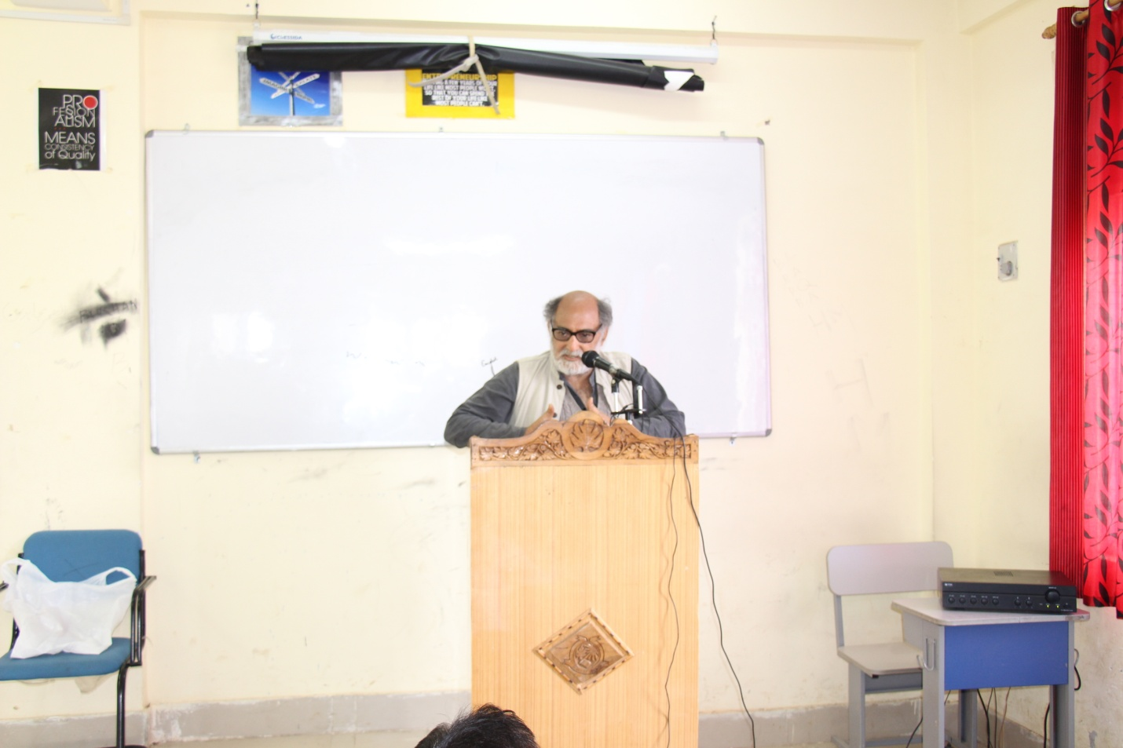
Professor Badri Raina speaking on “Marxism :How not to Read it?” at PG Department of English ,North Campus

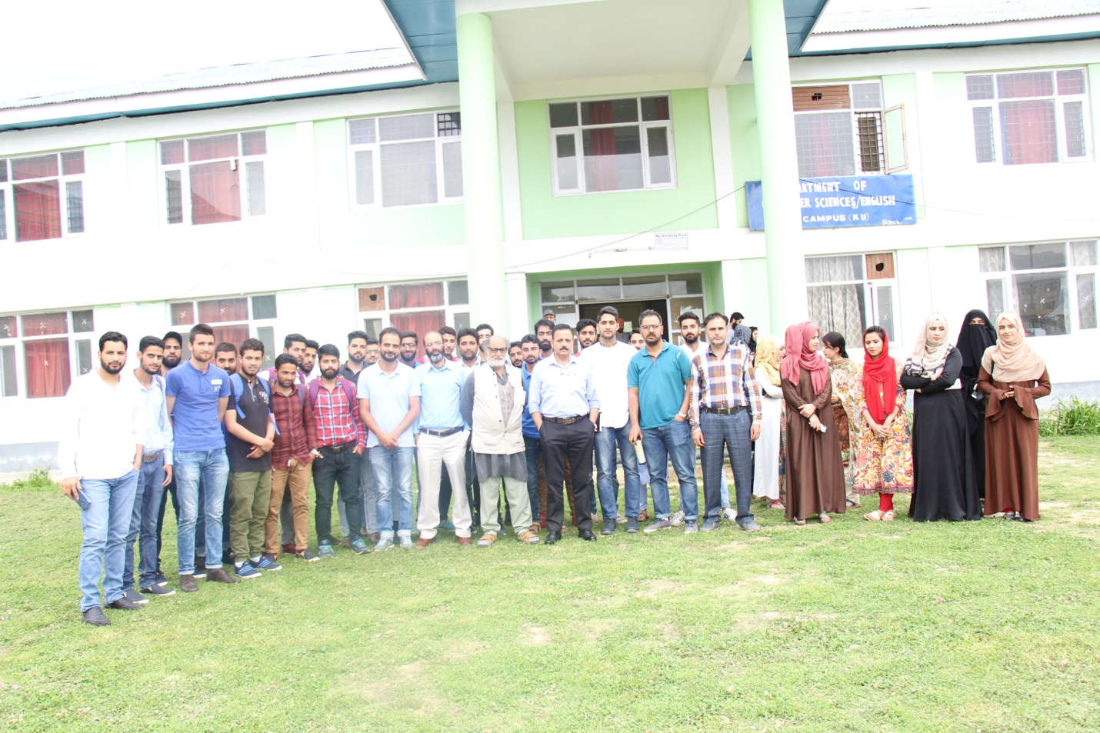
Professor Badri Raina and Director North Campus ,Professor Naseer Iqbal with faculty ,scholars and students
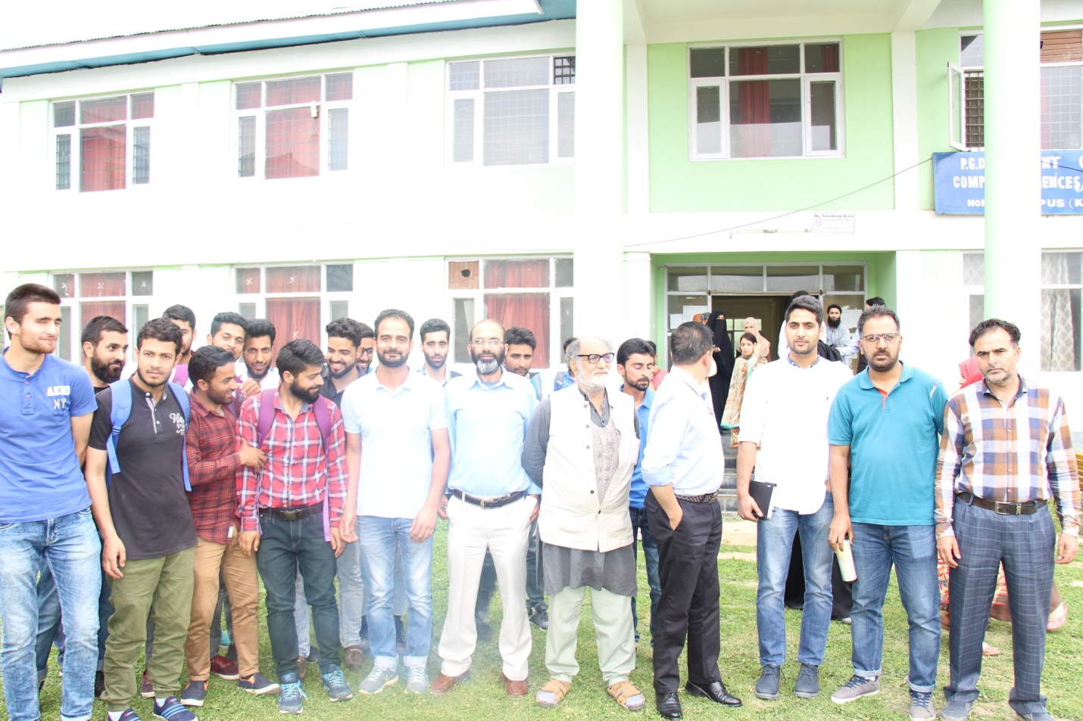

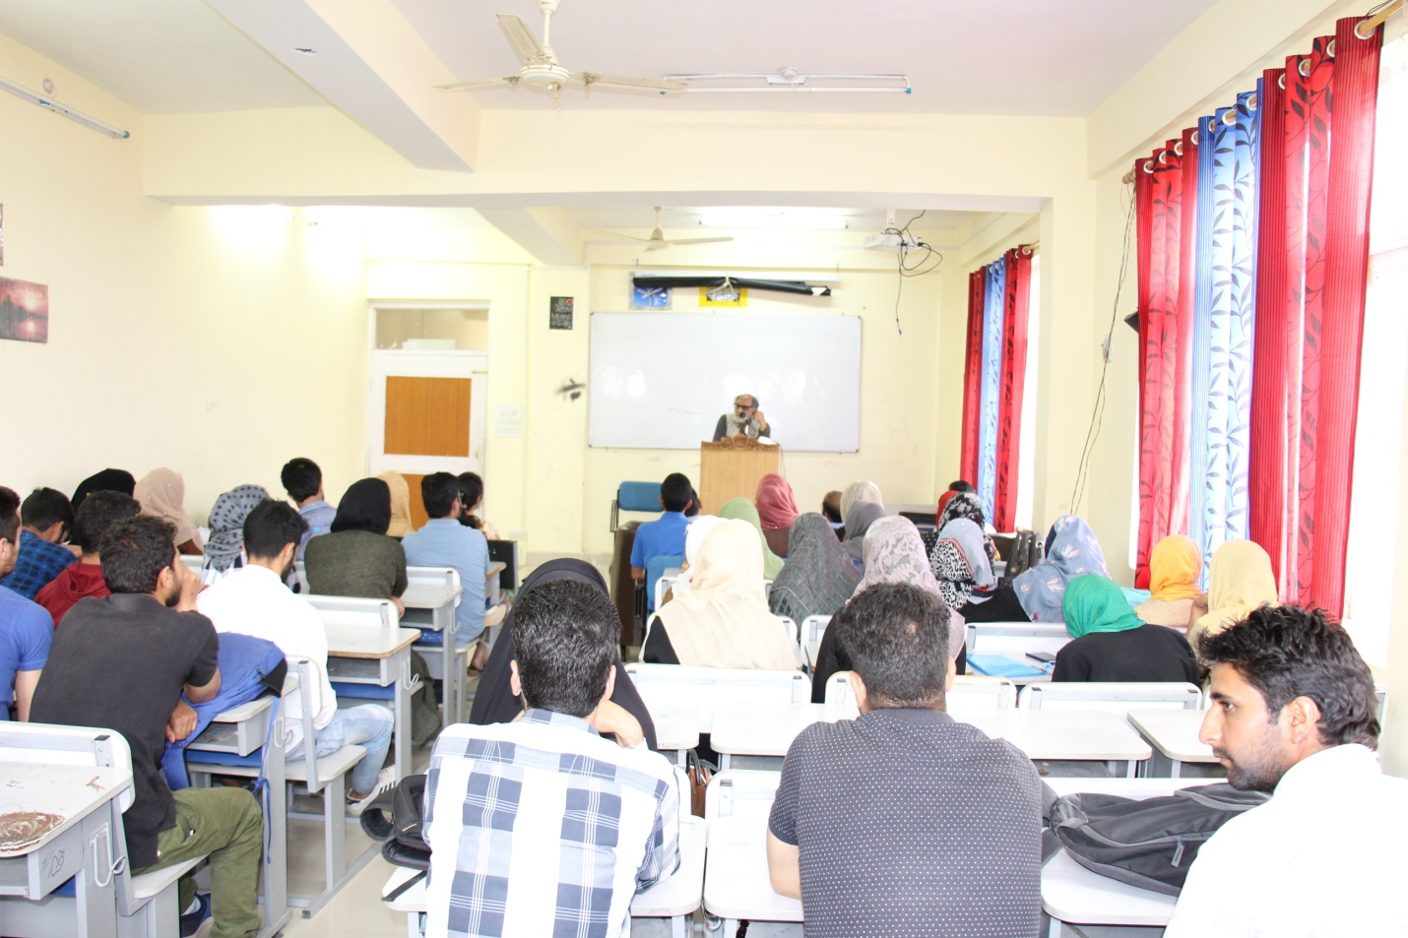

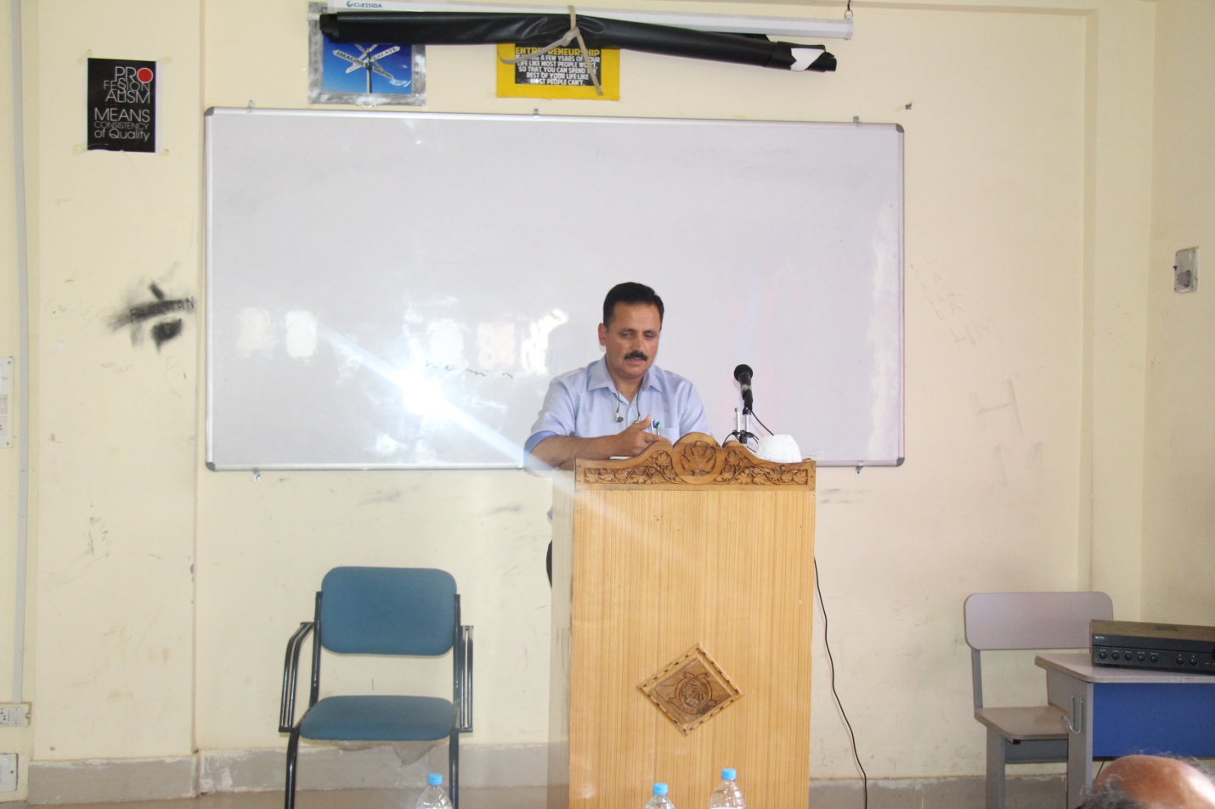
Director North Campus ,Professor Naseer Iqbal addressing the faculty ,scholars and students after the extension lecture by Professor Badri Raina

